**Make two tables and corresponding columns provided in the above CSV files in SQLite DBMS. Insert all data of each CSV file in each of the created tables. Now start querying the table(s) in the  SQL workbench / SQLite database :**

**Used SQLite DB to import csv files and executed the queries.**

1. Display all the details of movies created by directors Christopher and [Matt Reeves](https://www.imdb.com/name/nm0716257/?ref_=adv_li_dr_0).

SELECT * FROM data1 WHERE Director1 IN ('Christopher Nolan', 'Matt Reeves');

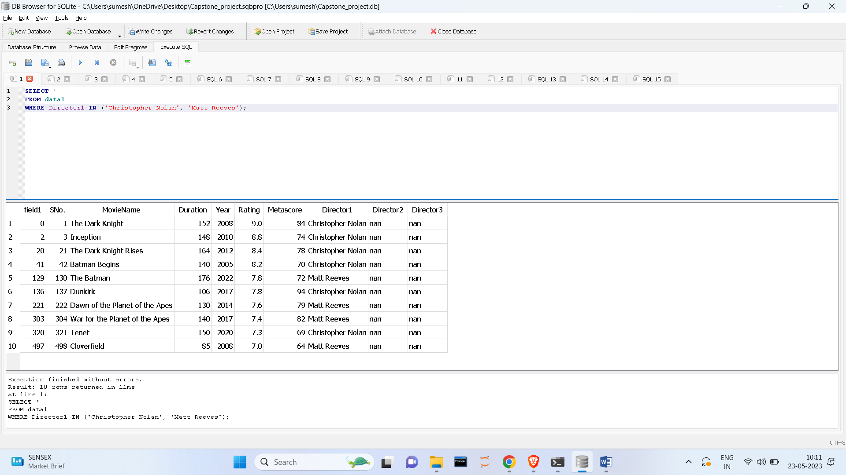

1. Display all the details of movies with a duration of 140 minutes to 190 minutes.

SELECT * FROM data1 WHERE Duration >= 140 AND Duration <= 190;

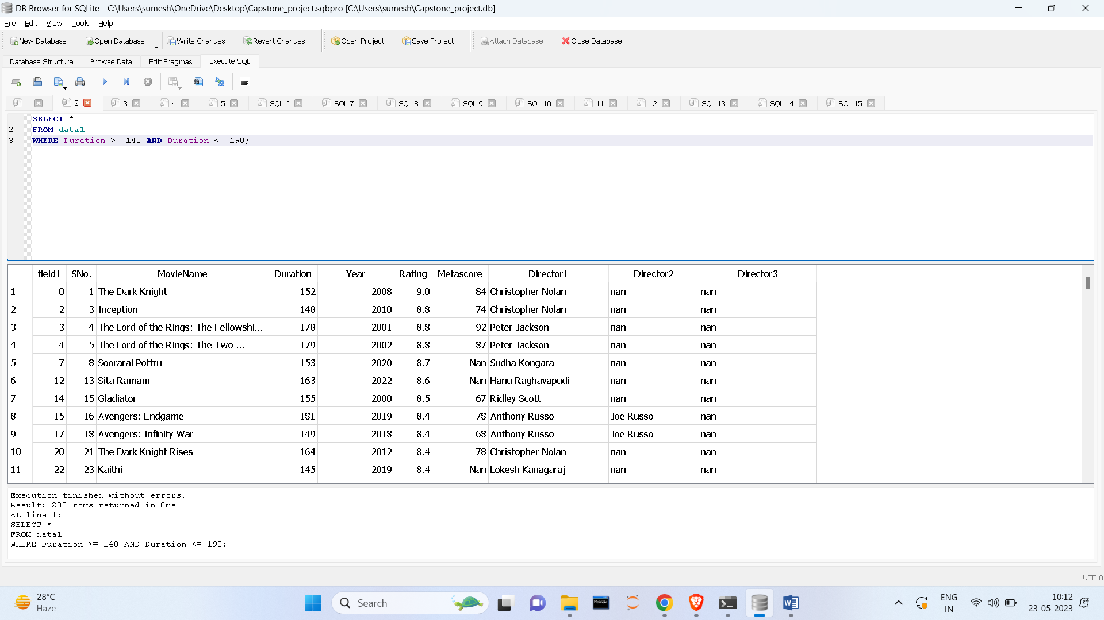

1. Display all details of movies with ratings above 7 in ascending order.

SELECT * FROM data1 WHERE Rating > 7 ORDER BY Rating ASC;

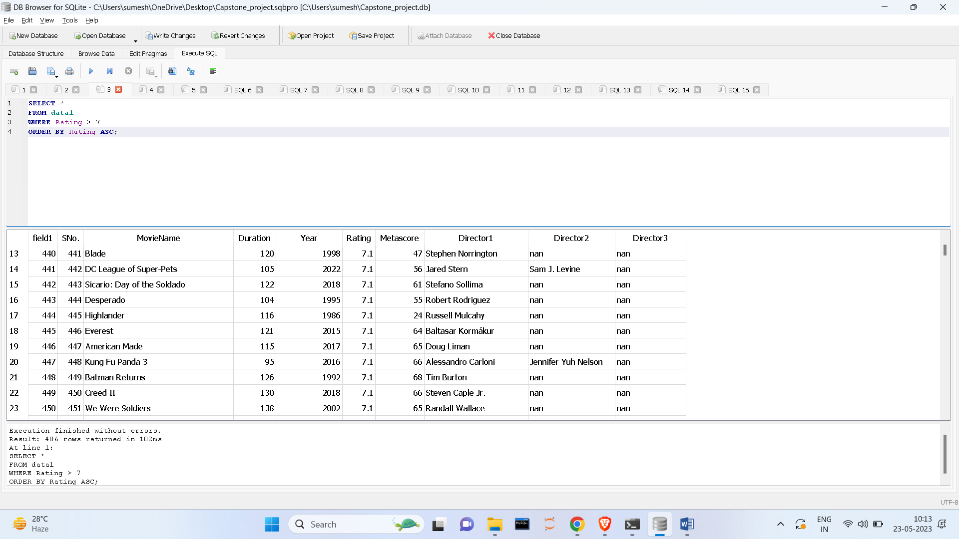

4) Display all movie names in descending order.

SELECT MovieName FROM data1 ORDER BY MovieName DESC;

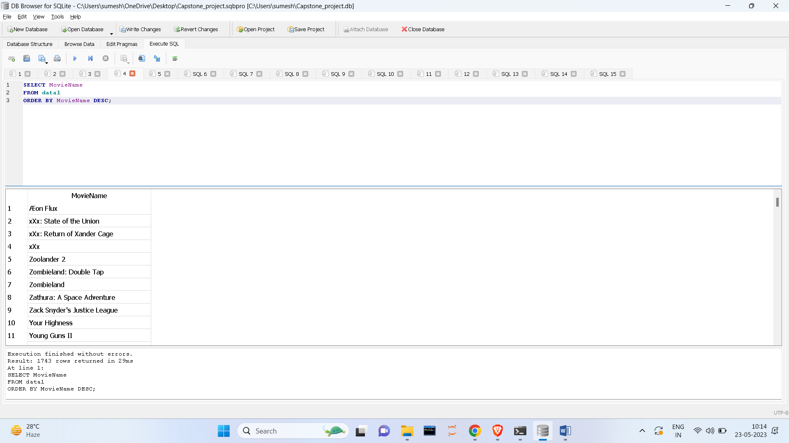  
  
  
  
5) Display movie name starts with ‘P’ and their rating is greater than 7.

SELECT MovieName FROM data1 WHERE MovieName LIKE 'P%' AND Rating > 7;

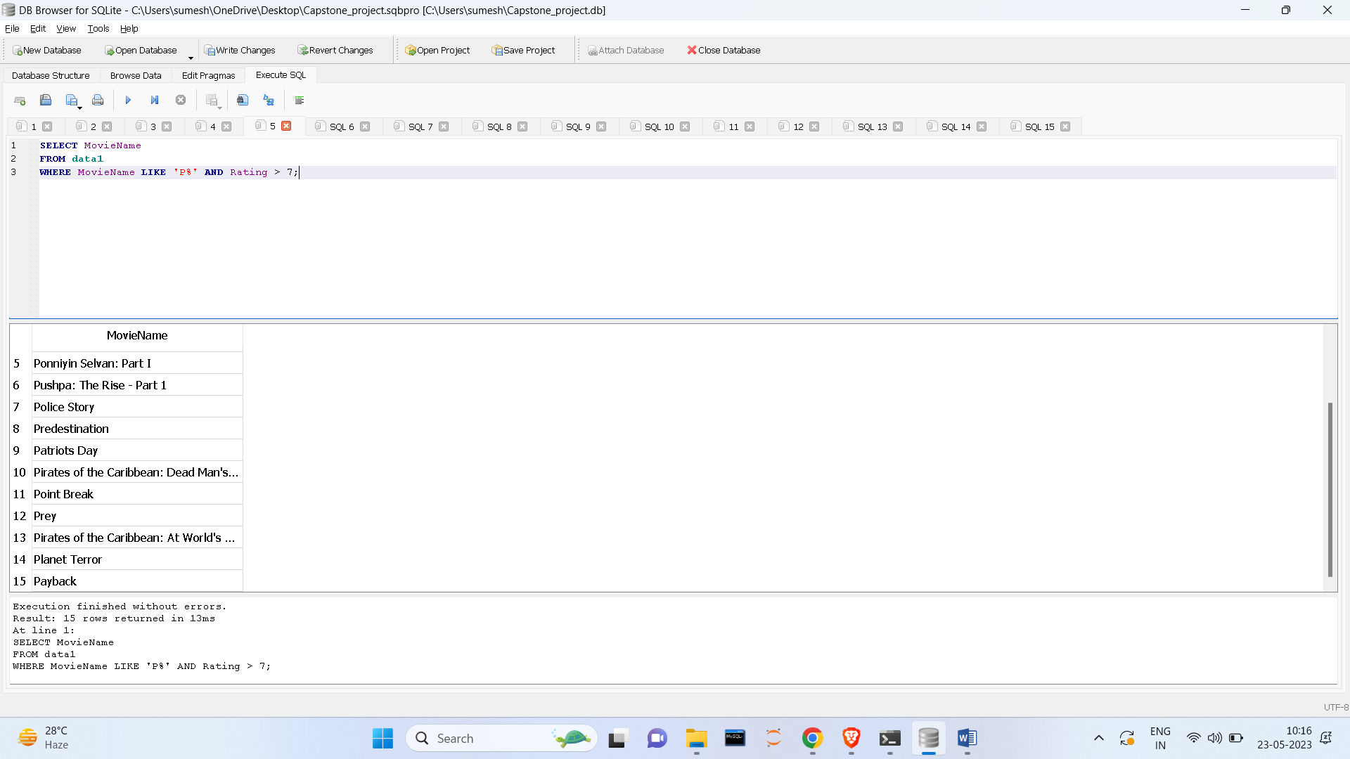  
  
  
1) Display all movie names with star [Arnold Schwarzenegger](https://www.imdb.com/name/nm0000216/?ref_=adv_li_st_0) in ascending order.

SELECT MovieName FROM data2 WHERE Star1 = 'Arnold Schwarzenegger' or Star2= 'Arnold Schwarzenegger' or Star3 = 'Arnold Schwarzenegger' or Star4= 'Arnold Schwarzenegger' ORDER BY MovieName ASC;

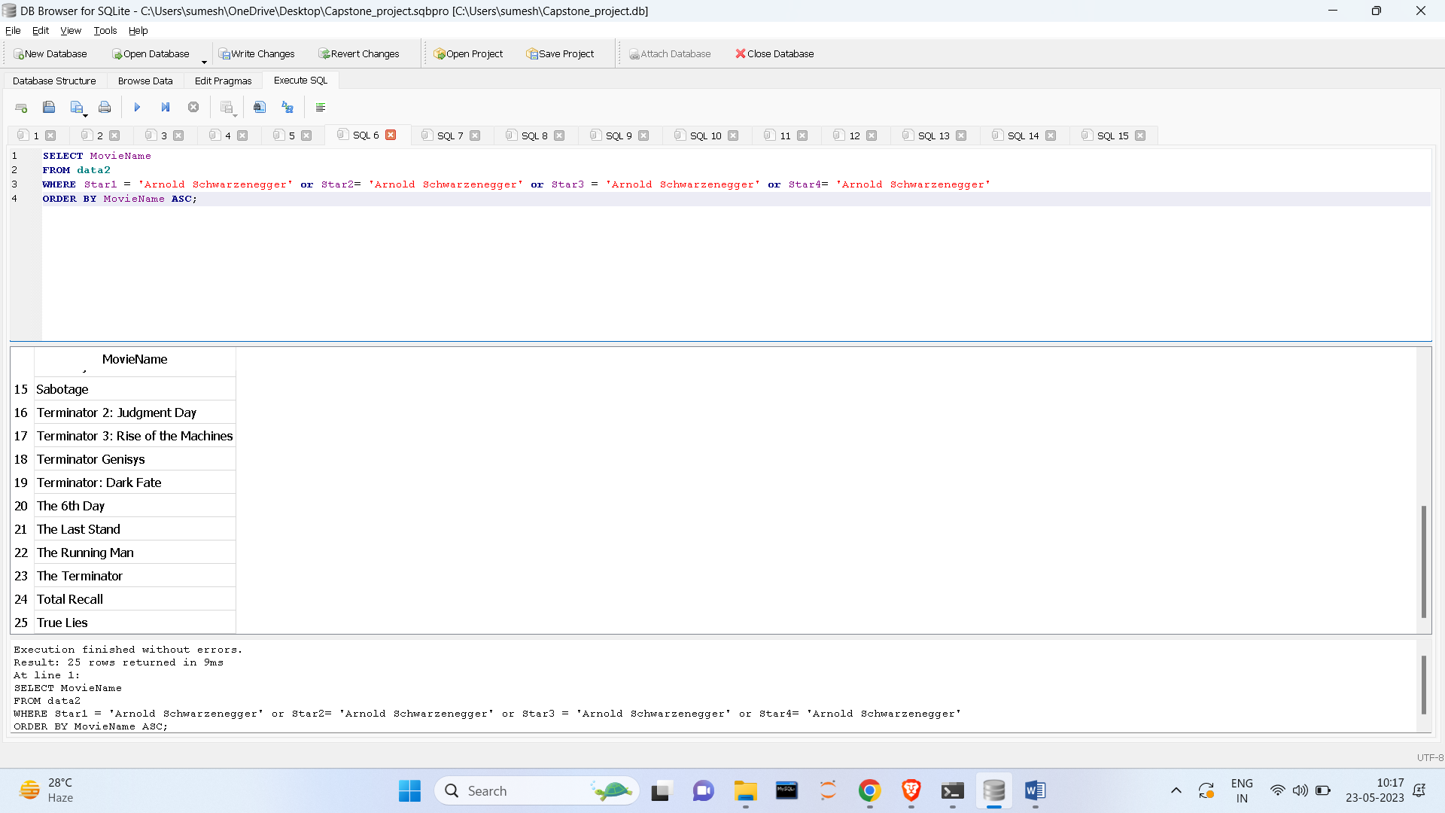

2) Display all details of the movie with the highest number of votes.

SELECT * FROM data2 WHERE votes = (SELECT MAX(votes) FROM data2);

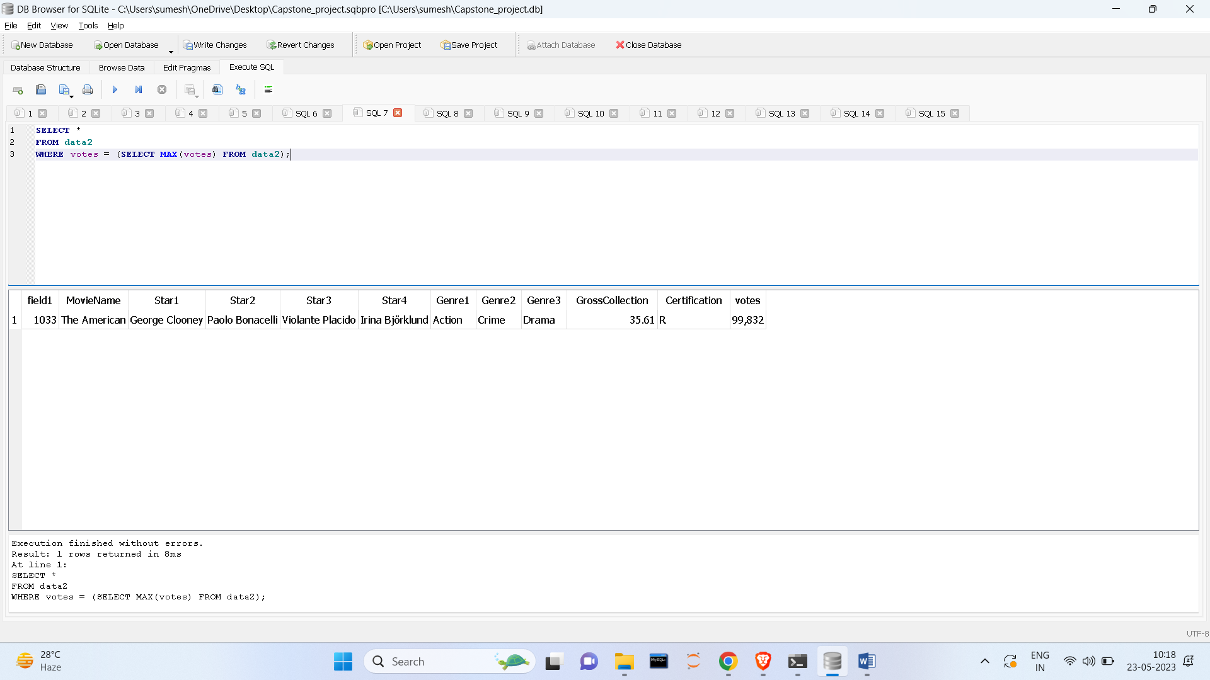

3) Display movie names with gross collections in descending order.

UPDATE data2 SET GrossCollection = NULL WHERE GrossCollection = 'Nan';

SELECT MovieName, GrossCollection FROM data2 WHERE GrossCollection IS NOT NULL ORDER BY GrossCollection DESC;

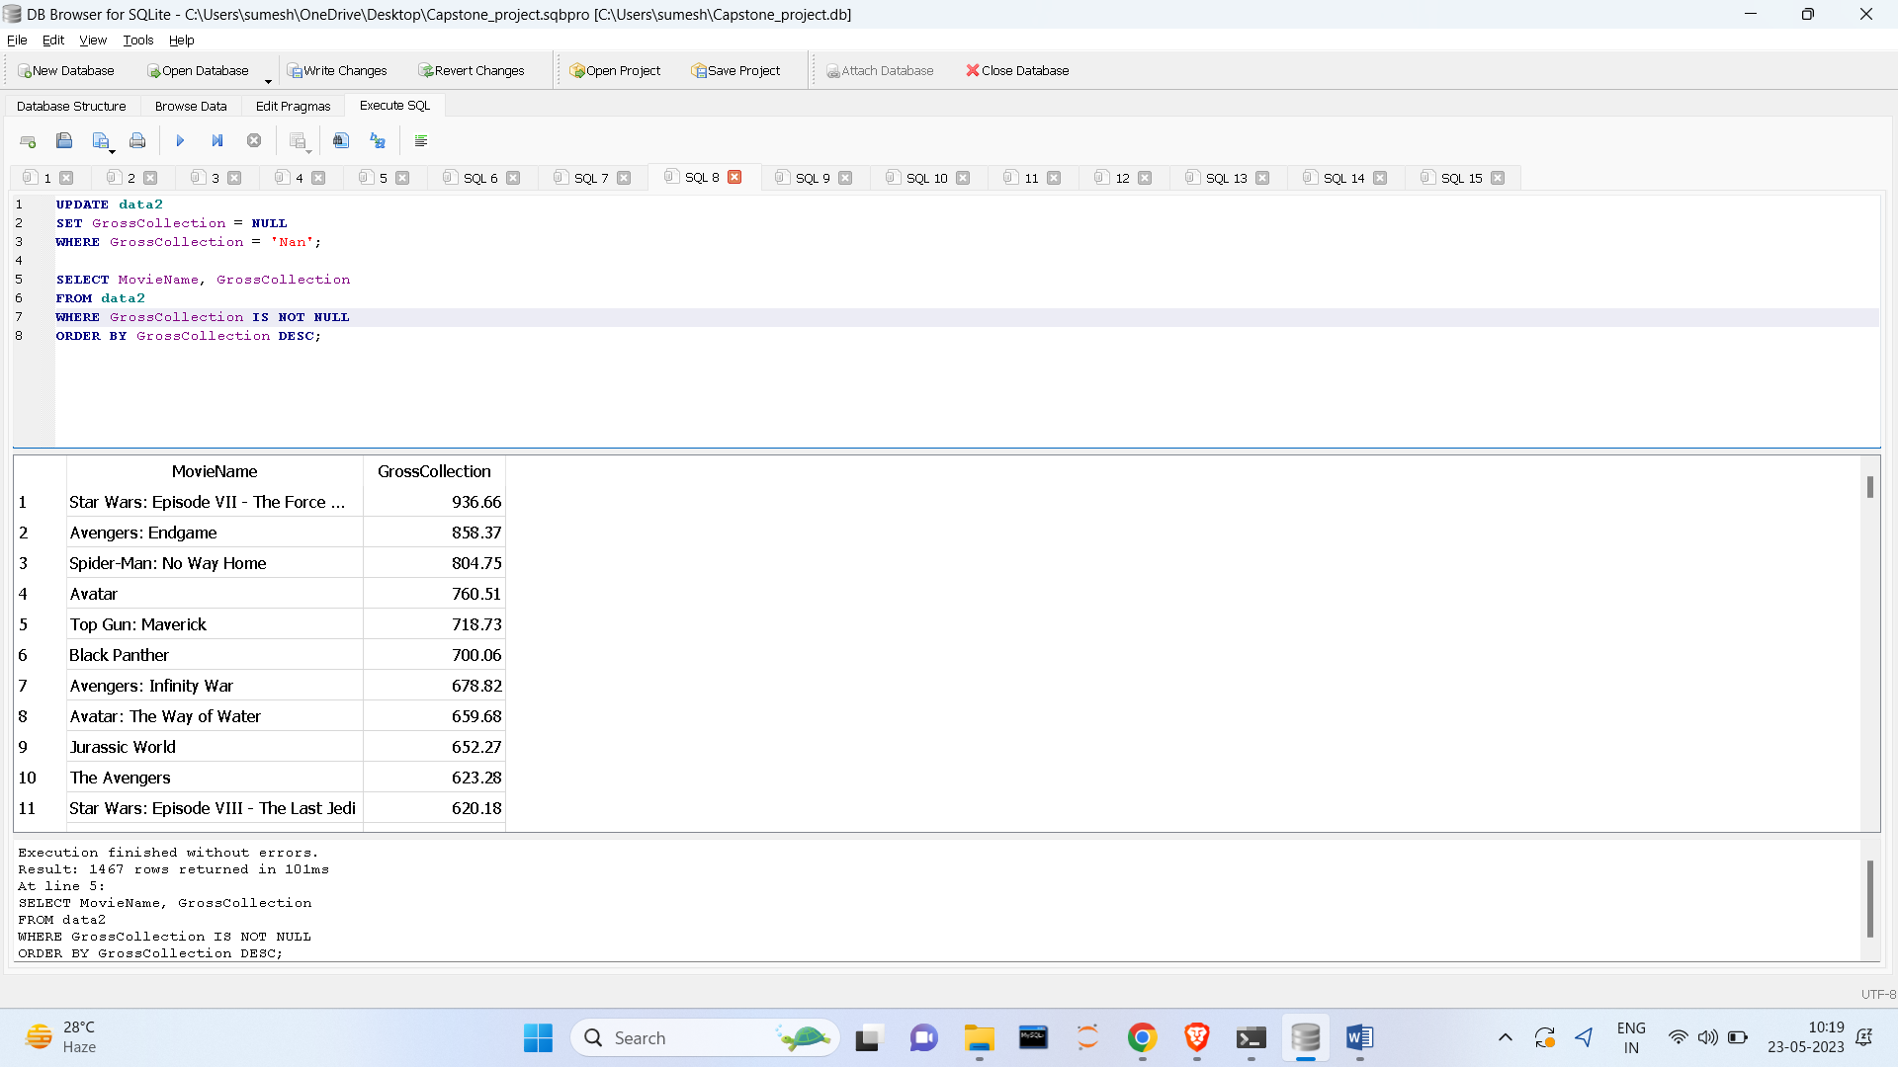

4) Display the gross collection of movies with the star Arnold.

SELECT MovieName, GrossCollection FROM data2 WHERE Star1 = 'Arnold Schwarzenegger'or Star2= 'Arnold Schwarzenegger' or Star3 = 'Arnold Schwarzenegger' or Star4= 'Arnold Schwarzenegger';

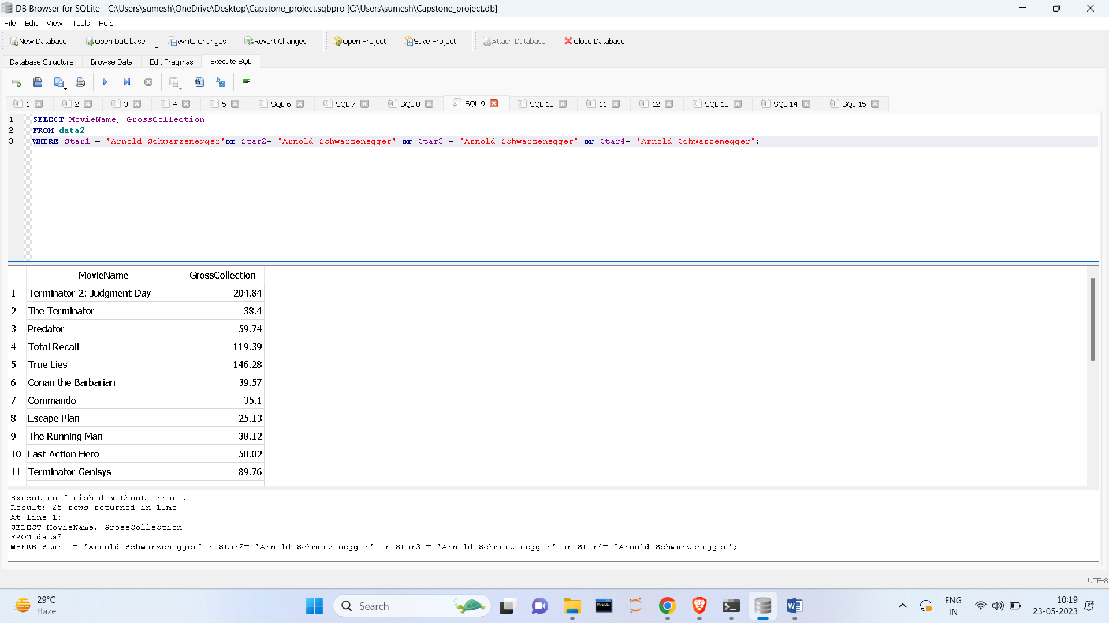

5) Display all details of movies with comedy and action genres.

SELECT * FROM data2 WHERE Genre1 IN ('Comedy', 'Action') or Genre2 IN ('Comedy', 'Action') or Genre3 IN ('Comedy', 'Action');

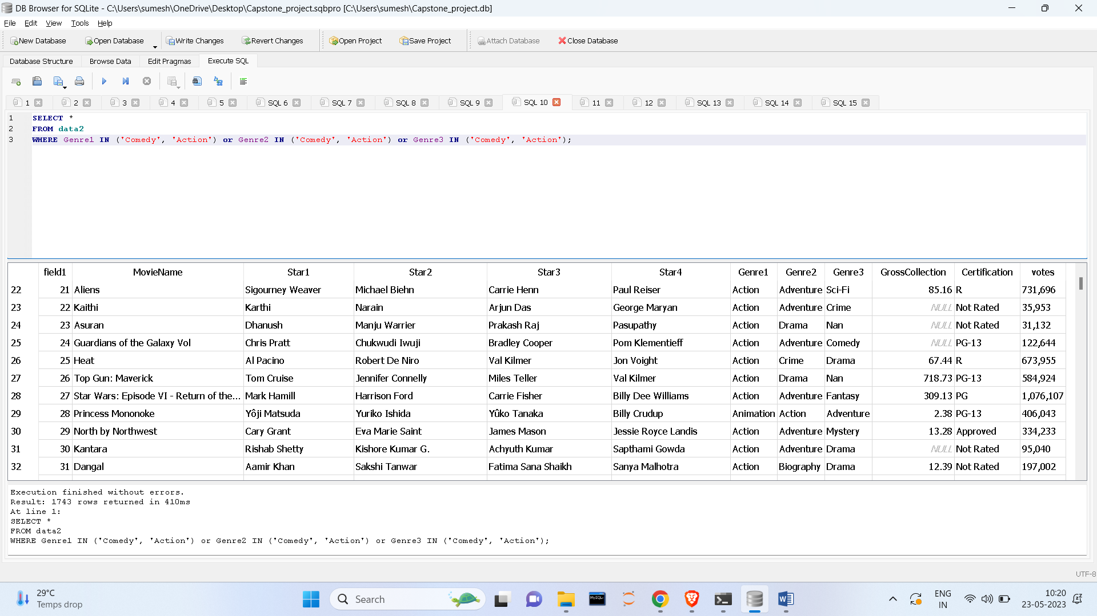  
  
  
  
  
  
  
  
  
  
  
  
  
  
  
  
  
  
  
  
  
  
  
  
  
  
  
  
  
  
  
1) Display all details from both tables where movie names are the same.

SELECT * FROM data1 JOIN data2 ON data1.MovieName = data2.MovieName;

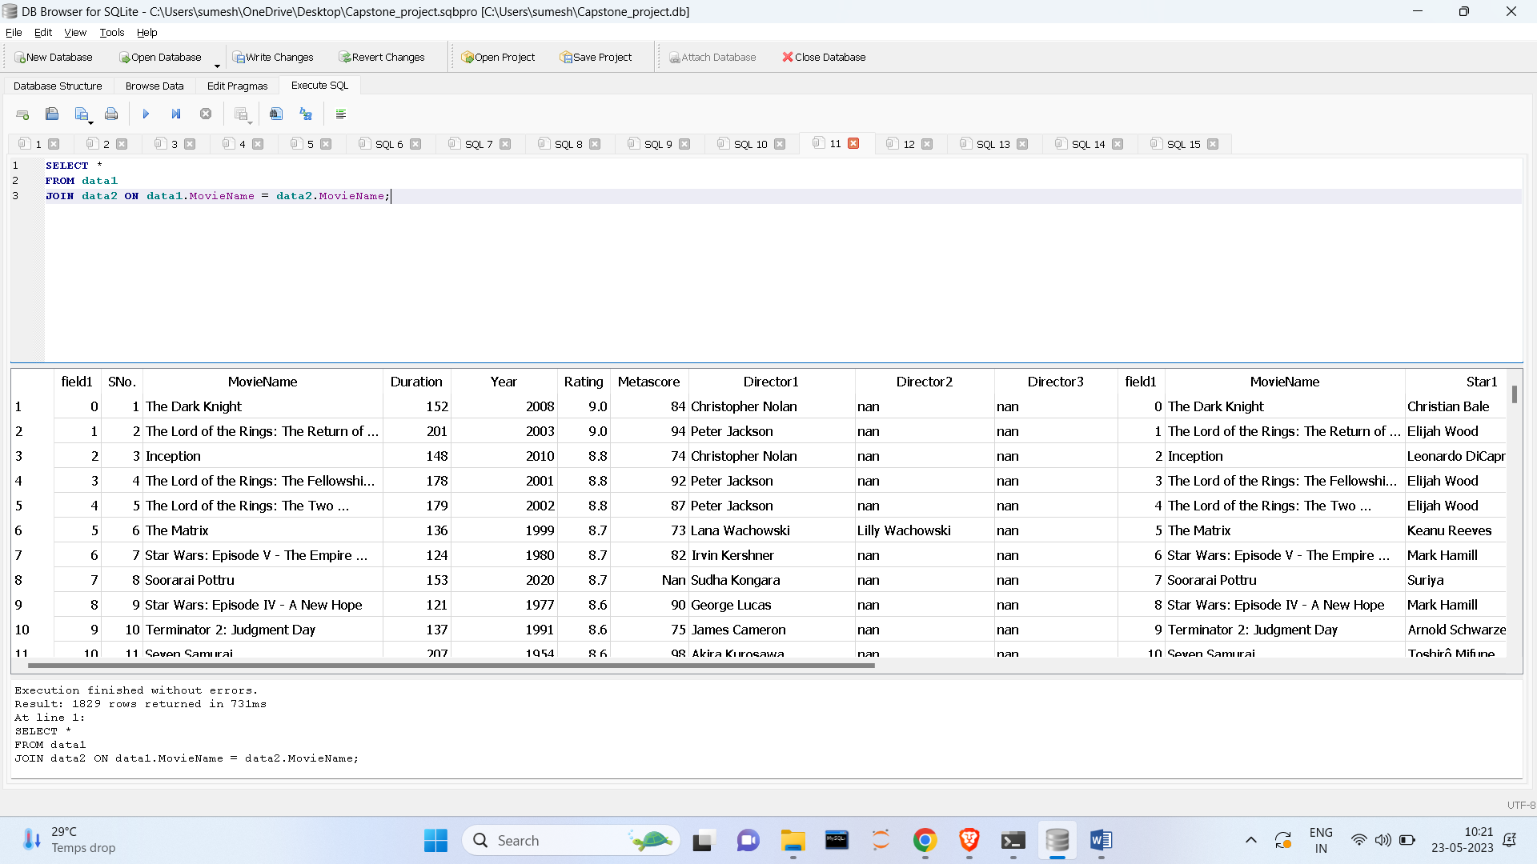

2)   Display all movie names, Director, ratings, and gross collection where the genre is action.

SELECT data1.MovieName, data1.Director1, data1.Rating, data2.GrossCollection, data2.Genre1

FROM data1, data2 WHERE (data2.Genre1 = 'Action' ) AND data1.MovieName = data2.MovieName;

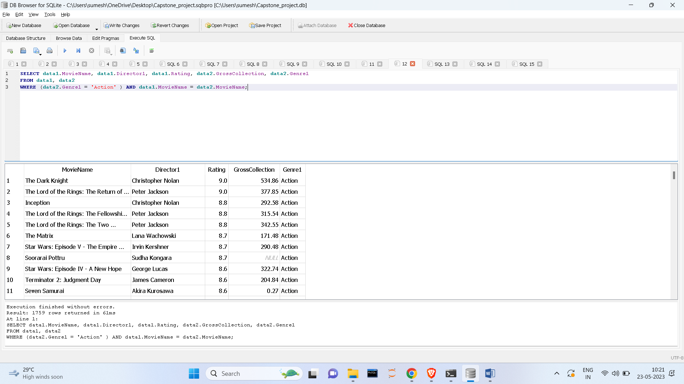

3)      Display all details from both tables with the highest gross collection.

SELECT * FROM data1, data2 WHERE data2.GrossCollection = (SELECT MAX(GrossCollection) FROM data2) AND data1.MovieName = data2.MovieName;

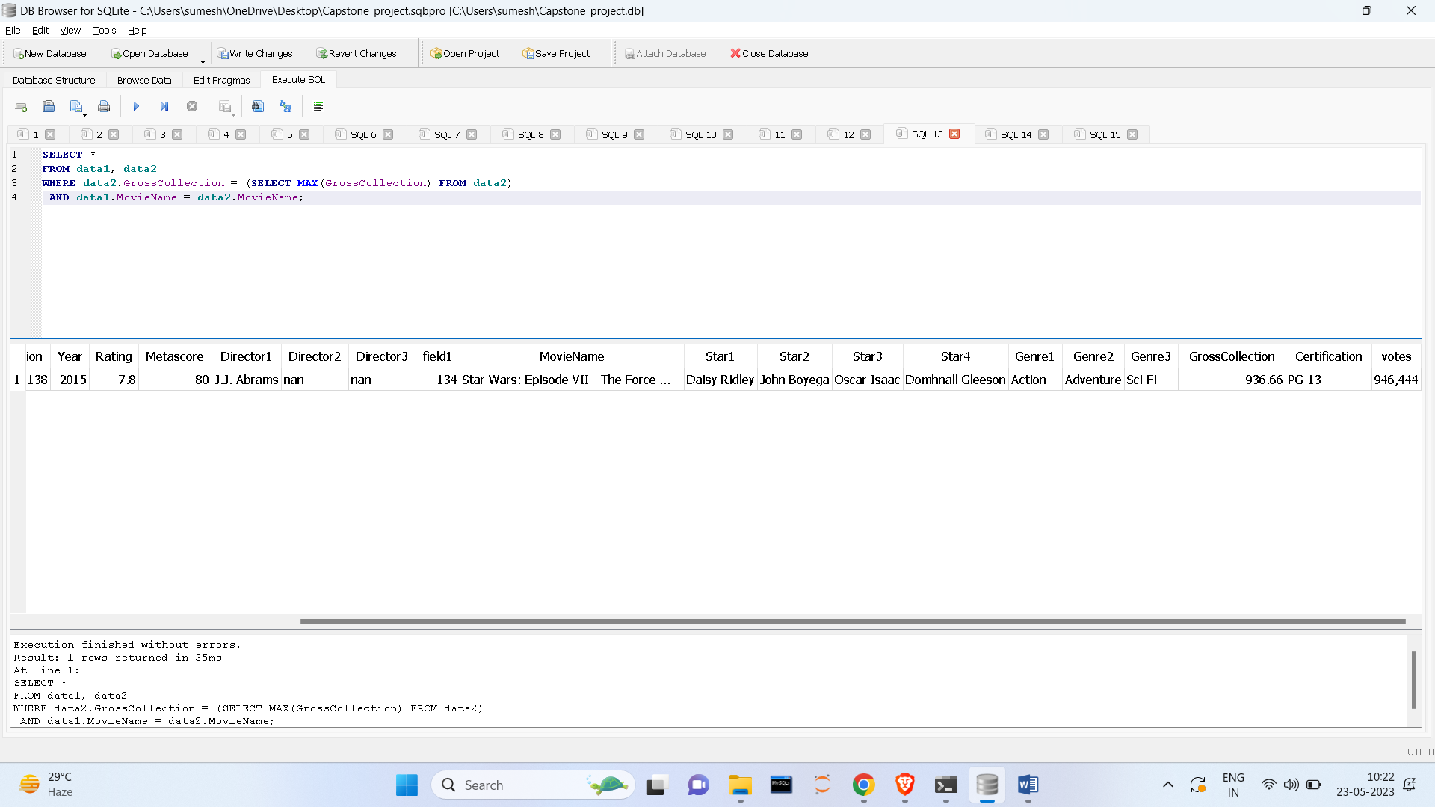

4)      Display all details from both tables with the highest ratings

SELECT * FROM data1, data2 WHERE data1.Rating = (SELECT MAX(Rating) FROM data1) AND data1.MovieName = data2.MovieName;

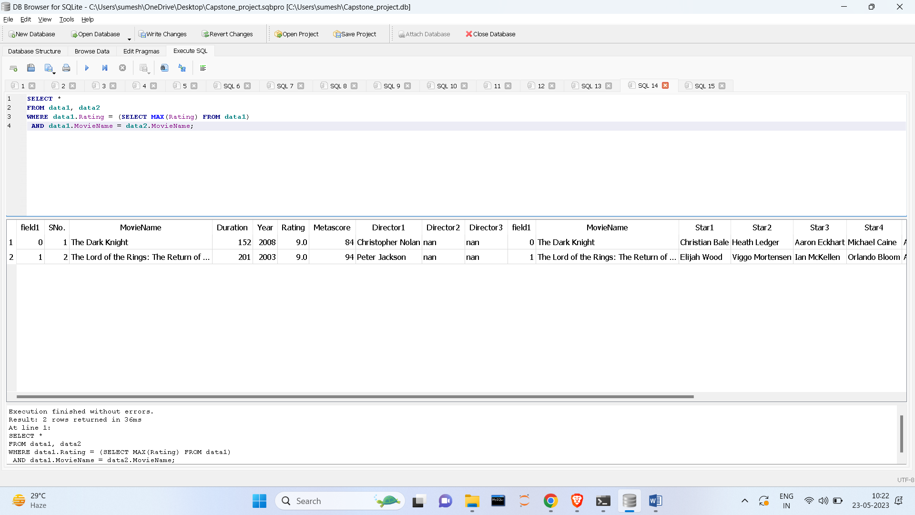

5)      Display all details from both tables with the lowest gross collection and lowest ratings

SELECT * FROM data1, data2 WHERE (data2.GrossCollection = (SELECT min(GrossCollection) FROM data2) OR data1.Rating=(SELECT min(Rating) FROM data1)) AND data1.MovieName = data2.MovieName;

